Network Fundamentals Quiz
Total points0/0
Section score0/0

1) A converged network is a network that has the capabilities of transporting multiple types of traffic such as voice, video, and data, which can offer significant cost savings to organizations.
True

False

2) Which of the matching from the following table is correct?
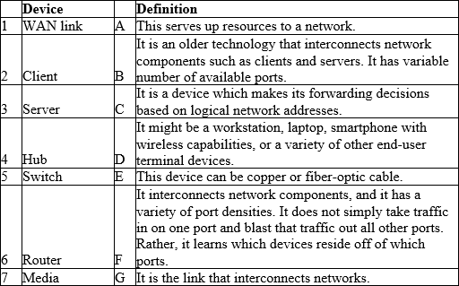
A) 1G, 2D, 3A, 4B, 5F, 6C, 7E

B) 1D, 2G, 3B, 4A, 5F, 6C, 7E

C) 1E, 2D, 3A, 4B, 5F, 6C, 7G

D) 1B, 2D, 3A, 4G, 5F, 6C, 7E

3) Which of the following is a not a network category based on the geographic dispersion of network components?
A) Local-area network (LAN)

B) World-area network (WAN)

C) Campus-area network (CAN)

D) Metropolitan-area network (MAN)

E) Personal-area network (PAN)

4) What is device type A and B in the following exhibit?
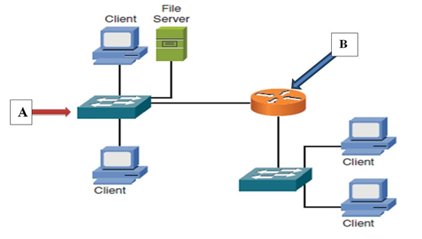
A) Device A is a switch, and device B is a hub.

B) Device A is a switch, and device B is a router.

C) Device A is a switch, and device B is a server.

D) Device A is a router, and device B is a switch.

5) What is the label of A in the following exhibit?
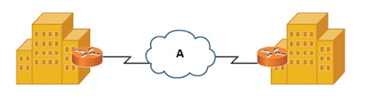
A) IP address

B) LAN link

C) IP WAN

D) Router

6) Which of the matching from the following diagram is correct?
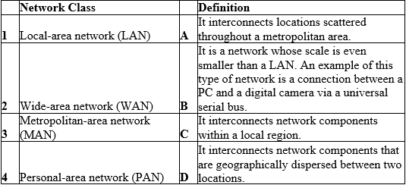
A) 1C, 2D, 3A, 4B

B) 1D, 2C, 3B, 4A

C) 1B, 2D, 3A, 4C

D) 1A, 2D, 3C, 4B

7) The actual traffic flow determines the logical topology, while how components are physically interconnected determines the physical topology.
True

False

8) Which of the matching from the following diagram is correct?
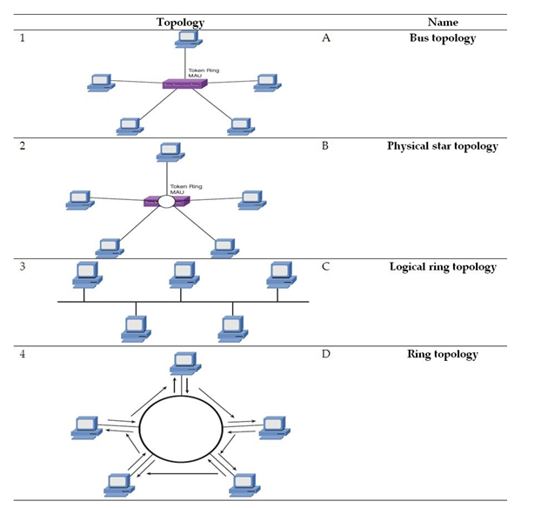
A) 1B, 2C, 3A, 4D

B) 1A, 2B, 3C, 4D

C) 1B, 2A, 3D, 4C

D) 1D, 2C, 3B, 4A

9) When you are interconnecting multiple sites (for example, multiple corporate locations) via WAN links, a hub-and-spoke topology has a WAN link from each remote site (a spoke site) to the main site (the hub site). The following diagram shows a hub-and-spoke topology.
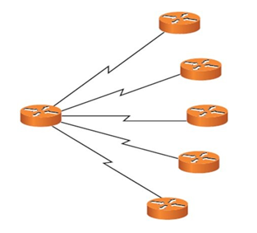
True

False

10) Which of the following applies to the diagram shown here? (Choose two.)
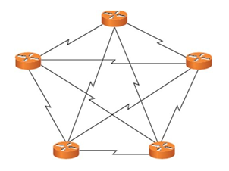
A) The diagram represents a full-mesh WAN topology.

B) It directly connects every site to every other site.

C) The directly connected sites allow suboptimal path to be located instead relaying traffic via another site.
D) There is a WAN link from each remote site to the main site.

11) Which of the following applies to client-server network? (Choose two.)
Option 1

A) Client/server networks are not commonly used by businesses.
B) Administration of client/server is more difficult than in a peer-to-peer network because the resources are located on one or more servers.
C) Client/server networks can have better performance than a peer-to-peer network because their resources can be located on dedicated servers rather than on a PC running a variety of end-user applications.

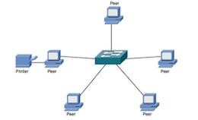
D) The following diagram represents a client/server network.

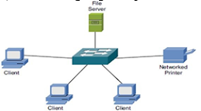
E) The following diagram represents a client/server network.
Correct answer

C) Client/server networks can have better performance than a peer-to-peer network because their resources can be located on dedicated servers rather than on a PC running a variety of end-user applications.
E) The following diagram represents a client/server network.

12) Which of the following applies to peer-to-peer networks? (Choose two.)
A) Peer-to-peer networks allow interconnected devices to share their resources with one another.

B) Peer-to-peer networks are commonly seen in large enterprises.
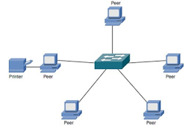
C) The following diagram represents a peer-to-peer network.

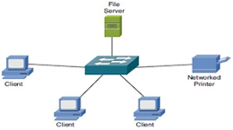
D) The following diagram represents a peer-to-peer network.
Correct answer

A) Peer-to-peer networks allow interconnected devices to share their resources with one another.
D) The following diagram represents a peer-to-peer network.

13) Which of the following statements is true? (Choose two.)
A) Client/server networks can easily scale, which might require the purchase of additional client licenses.

B) Client/server networks can cost more than peer-to-peer networks. For example, client/server networks might require the purchase of dedicated server hardware and a network OS with an appropriate number of licenses.

C) Peer-to-peer networks can be very difficult to install.
D) Peer-to-peer networks typically cost more than client/server networks because there is no requirement for dedicated server resources or advanced NOS software.

14) What is the name of the address that is used by a switch to identify specific devices?
A) MAC

B) IP

C) LLC

D) ARP

15) What is the name of the address that is used by a router (at Layer 3) to identify specific devices?
A) MAC

B) IP

C) LLC

D) ARP

16) Which IEEE standard defines wired Ethernet as it is used on modern networks?
A) 802.5

B) 802.16

C) 802.3

D) 802.1

17) A Bluetooth connection between a mobile phone and a headset is an example of what type of network category?
A) CAN

B) LAN

C) MAN

D) PAN

18) An FDDI network uses which type of topology?
A) Dual ring

B) Ring

C) Star

D) Bus

Correct answer
A) Dual ring

19) What is the most popular topology that is used on modern LANs?
A) Bus

B) Star

C) Ring

D) Partial mesh

Correct answer
B) Star

20) Which option is a benefit of implementing a client/server arrangement over a peer-to-peer arrangement? (Choose two.)
A) Easy installation
B) Cheaper
C) Simplified administration

D) Easy scalability

This content is neither created nor endorsed by Google. - Terms of Service - Privacy Policy

Forms
###################################################################################
Network Fundamentals Quiz
Total points0/0
Section score0/0

1) A converged network is a network that has the capabilities of transporting multiple types of traffic such as voice, video, and data, which can offer significant cost savings to organizations.
True
Correct

False

2) Which of the matching from the following table is correct?
A) 1G, 2D, 3A, 4B, 5F, 6C, 7E
Correct

B) 1D, 2G, 3B, 4A, 5F, 6C, 7E
C) 1E, 2D, 3A, 4B, 5F, 6C, 7G
D) 1B, 2D, 3A, 4G, 5F, 6C, 7E

3) Which of the following is a not a network category based on the geographic dispersion of network components?
A) Local-area network (LAN)
B) World-area network (WAN)
Correct

C) Campus-area network (CAN)
D) Metropolitan-area network (MAN)
E) Personal-area network (PAN)

4) What is device type A and B in the following exhibit?
A) Device A is a switch, and device B is a hub.
B) Device A is a switch, and device B is a router.
Correct

C) Device A is a switch, and device B is a server.
D) Device A is a router, and device B is a switch.

5) What is the label of A in the following exhibit?
A) IP address
B) LAN link
C) IP WAN
Correct

D) Router

6) Which of the matching from the following diagram is correct?
A) 1C, 2D, 3A, 4B
Correct

B) 1D, 2C, 3B, 4A
C) 1B, 2D, 3A, 4C
D) 1A, 2D, 3C, 4B

7) The actual traffic flow determines the logical topology, while how components are physically interconnected determines the physical topology.
True
Correct

False

8) Which of the matching from the following diagram is correct?
A) 1B, 2C, 3A, 4D
Correct

B) 1A, 2B, 3C, 4D
C) 1B, 2A, 3D, 4C
D) 1D, 2C, 3B, 4A

9) When you are interconnecting multiple sites (for example, multiple corporate locations) via WAN links, a hub-and-spoke topology has a WAN link from each remote site (a spoke site) to the main site (the hub site). The following diagram shows a hub-and-spoke topology.
True
Correct

False

10) Which of the following applies to the diagram shown here? (Choose two.)
A) The diagram represents a full-mesh WAN topology.
Correct

B) It directly connects every site to every other site.
Correct

C) The directly connected sites allow suboptimal path to be located instead relaying traffic via another site.
D) There is a WAN link from each remote site to the main site.

11) Which of the following applies to client-server network? (Choose two.)
Option 1
A) Client/server networks are not commonly used by businesses.
B) Administration of client/server is more difficult than in a peer-to-peer network because the resources are located on one or more servers.
C) Client/server networks can have better performance than a peer-to-peer network because their resources can be located on dedicated servers rather than on a PC running a variety of end-user applications.
Correct

D) The following diagram represents a client/server network.
Incorrect

E) The following diagram represents a client/server network.

Correct answer
C) Client/server networks can have better performance than a peer-to-peer network because their resources can be located on dedicated servers rather than on a PC running a variety of end-user applications.
E) The following diagram represents a client/server network.

12) Which of the following applies to peer-to-peer networks? (Choose two.)
A) Peer-to-peer networks allow interconnected devices to share their resources with one another.
Correct

B) Peer-to-peer networks are commonly seen in large enterprises.
C) The following diagram represents a peer-to-peer network.
Incorrect

D) The following diagram represents a peer-to-peer network.

Correct answer
A) Peer-to-peer networks allow interconnected devices to share their resources with one another.
D) The following diagram represents a peer-to-peer network.

13) Which of the following statements is true? (Choose two.)
A) Client/server networks can easily scale, which might require the purchase of additional client licenses.
Correct

B) Client/server networks can cost more than peer-to-peer networks. For example, client/server networks might require the purchase of dedicated server hardware and a network OS with an appropriate number of licenses.
Correct

C) Peer-to-peer networks can be very difficult to install.
D) Peer-to-peer networks typically cost more than client/server networks because there is no requirement for dedicated server resources or advanced NOS software.

14) What is the name of the address that is used by a switch to identify specific devices?
A) MAC
Correct

B) IP
C) LLC
D) ARP

15) What is the name of the address that is used by a router (at Layer 3) to identify specific devices?
A) MAC
B) IP
Correct

C) LLC
D) ARP

16) Which IEEE standard defines wired Ethernet as it is used on modern networks?
A) 802.5
B) 802.16
C) 802.3
Correct

D) 802.1

17) A Bluetooth connection between a mobile phone and a headset is an example of what type of network category?
A) CAN
B) LAN
C) MAN
D) PAN
Correct

18) An FDDI network uses which type of topology?
A) Dual ring
B) Ring
Incorrect

C) Star
D) Bus
Correct answer
A) Dual ring

19) What is the most popular topology that is used on modern LANs?
A) Bus
B) Star
C) Ring
D) Partial mesh
Incorrect

Correct answer
B) Star

20) Which option is a benefit of implementing a client/server arrangement over a peer-to-peer arrangement? (Choose two.)
A) Easy installation
B) Cheaper
C) Simplified administration
Correct

D) Easy scalability
Correct

This content is neither created nor endorsed by Google. - Terms of Service - Privacy Policy
Forms

https://docs.google.com/forms/d/e/1FAIpQLScbCxVkM_hIcyHkZCKtI08CfV-Ppb_vNM7poql9kfF2RM4-pA/viewscore?viewscore=AE0zAgDrGc6gkIzoBX-aCEvTyjBMbfQPbxyjX-VTCoF74K8rlc9JmRLvGVpYhnCqcIUcHk4
OSI Reference Model Quiz
Total points0/0
Section score0/0

1) Which of the following is not a layer of the Open Systems Interconnect (OSI) reference model?
A) Physical layer

B) Data link layer

C) Internet access layer

D) Presentation layer

2) What layer of the OSI corresponds to label A and B?
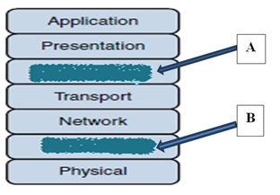
A) A is the host-to-host layer, and B is the Internet access layer.

B) A is the session layer, and B is the application layer.

C) A is the session layer, and B is the data link layer.

D) A is the session layer, and B is the physical layer.

3) At upper layers of the OSI reference model, bits are grouped together into protocol data units (PDUs) or data service units.
True

False

4) The term packet is used fairly generically to refer to protocol data unit (PDU). There are PDU equivalent names in the different OSI layers. What is the name of the unit in the physical layer of the OSI reference model?
A) Segment

B) Frames

C) Bits

D) Packet

6) Which of the following is not a characteristic of the Media Access Control (MAC) sublayer of the data link layer (Layer 2) of the OSI reference layered model?
A) The MAC sublayer uses a physical address call a MAC address, which is a 48-bit (6-byte) address assigned to a device network interface card.

B) Layer 2 devices view a network as a logical topology.

C) Method of transmitting on the media.

D) The use of flow control on a network to prevent a receiver from being overwhelmed.

Correct answer
D) The use of flow control on a network to prevent a receiver from being overwhelmed.

7) Which of the following layers of the OSI reference model is primarily concerned with forwarding data based on logical addresses?
A) Physical layer

B) Data link layer

C) Network layer

D) Presentation layer

8) Switching is associated with Layer 2 (data link layer) and Layer 3 (network layer).
True

False

Correct answer
True

9) Which of the following transport layer protocol of the OSI reference model is a connection-oriented protocol that provides reliable transport between two communicating hosts?
A) Transmission Control Protocol (TCP)

B) Transport Control Protocol (TCP)

C) User datagram Protocol (UDP)

D) Internetwork Packet Exchange (IPX)

10) Which OSI reference model layer is responsible for the following? (a) Setting up session (b) Maintaining a session (c) Tearing down a session
A) Presentation layer (Layer 6)

B) Data link layer (Layer 2)

C) Session layer (Layer 5)

D) Transport layer (layer 4)

11) John, the network administrator of XYZ Corporation, is interested in changing the format of text from American Standard Code for Information Interchange (ASCII) to Extended Binary Code Decimal Interchange Code (EBCDIC). In addition, his IT manager requested that all sensitive and confidential information on their servers should be protected by applying the appropriate encryption. What OSI reference model layer is responsible for data format such as encryption?
A) Presentation layer (Layer 6)

B) Data-link layer (Layer 2)

C) Session layer (Layer 5)

D) Transport layer (Layer 4)

12) Which of the following layers is not part of the TCP/IP protocol stack?
A) Transport

B) Application

C) Presentation

D) Internet

13) What is segment format A and B?
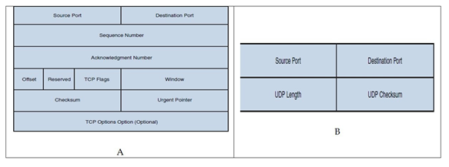
A) A is UDP segment format, and B is a TCP segment format.

B) A is TCP segment format, and B is a UDP segment format.

C) A is IPX segment format, and B is a SPX segment format.

D) A is SPX segment format, and B is a IPX segment format.

14) Which of the following protocol to TCP port matching is correct?
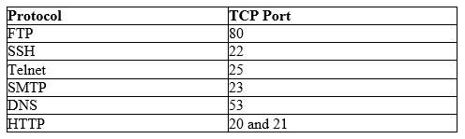
A) FTP 20 and 21, SSH 22, Telnet 23, SMTP 25, DNS 53, HTTP 80

B) FTP 20 and 21, SSH 23, Telnet 25, SMTP 25, DNS 80, HTTP 53

C) FTP 20 and 21, SSH 22, Telnet 25, SMTP 23, DNS 53, HTTP 80

D) FTP 20 and 23, SSH 22, Telnet 25, SMTP 25, DNS 53, HTTP 80

15) Which of the following protocol to TCP port matching is correct?
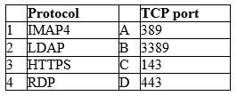
A) 1A, 2B, 3C, 4D

B) 1C, 2A, 3D, 4B

C) 1A, 2C, 3D, 4B

D) 1B, 2A, 3C, 4D

16) Which wiring standard is used on modern Ethernet connectors and jacks?
A) TIA/EIA-568-B

B) TIA/EIA-568-A

C) IEEE 802.3

D) IEEE 802.2

Correct answer
A) TIA/EIA-568-B

17) Broadband bandwidth usage divides the bandwidth into channels for use with multiple communications streams.
True

False

18) Which type of transmission synchronization technique uses start and stop bits at the beginning and end of a data frame?
A) Synchronous

B) Isochronous

C) Asynchronous

D) Biochronous

19) What is the name of the mechanism used by TCP to increase and decrease the number of segments that are sent between each other before an acknowledgment is required?
A) Buffering

B) Synchronizing

C) Scaling

D) Windowing

This content is neither created nor endorsed by Google. - Terms of Service - Privacy Policy
Forms
OSI Reference Model Quiz
Total points0/0
Section score0/0

1) Which of the following is not a layer of the Open Systems Interconnect (OSI) reference model?
A) Physical layer
B) Data link layer
C) Internet access layer
Correct

D) Presentation layer

2) What layer of the OSI corresponds to label A and B?
A) A is the host-to-host layer, and B is the Internet access layer.
B) A is the session layer, and B is the application layer.
C) A is the session layer, and B is the data link layer.
Correct

D) A is the session layer, and B is the physical layer.

3) At upper layers of the OSI reference model, bits are grouped together into protocol data units (PDUs) or data service units.
True
Correct

False

4) The term packet is used fairly generically to refer to protocol data unit (PDU). There are PDU equivalent names in the different OSI layers. What is the name of the unit in the physical layer of the OSI reference model?
A) Segment
B) Frames
C) Bits
Correct

D) Packet

6) Which of the following is not a characteristic of the Media Access Control (MAC) sublayer of the data link layer (Layer 2) of the OSI reference layered model?
A) The MAC sublayer uses a physical address call a MAC address, which is a 48-bit (6-byte) address assigned to a device network interface card.
B) Layer 2 devices view a network as a logical topology.
Incorrect

C) Method of transmitting on the media.
D) The use of flow control on a network to prevent a receiver from being overwhelmed.
Correct answer
D) The use of flow control on a network to prevent a receiver from being overwhelmed.

7) Which of the following layers of the OSI reference model is primarily concerned with forwarding data based on logical addresses?
A) Physical layer
B) Data link layer
C) Network layer
Correct

D) Presentation layer

8) Switching is associated with Layer 2 (data link layer) and Layer 3 (network layer).
True
False
Incorrect

Correct answer
True

9) Which of the following transport layer protocol of the OSI reference model is a connection-oriented protocol that provides reliable transport between two communicating hosts?
A) Transmission Control Protocol (TCP)
Correct

B) Transport Control Protocol (TCP)
C) User datagram Protocol (UDP)
D) Internetwork Packet Exchange (IPX)

10) Which OSI reference model layer is responsible for the following? (a) Setting up session (b) Maintaining a session (c) Tearing down a session
A) Presentation layer (Layer 6)
B) Data link layer (Layer 2)
C) Session layer (Layer 5)
Correct

D) Transport layer (layer 4)

11) John, the network administrator of XYZ Corporation, is interested in changing the format of text from American Standard Code for Information Interchange (ASCII) to Extended Binary Code Decimal Interchange Code (EBCDIC). In addition, his IT manager requested that all sensitive and confidential information on their servers should be protected by applying the appropriate encryption. What OSI reference model layer is responsible for data format such as encryption?
A) Presentation layer (Layer 6)
Correct

B) Data-link layer (Layer 2)
C) Session layer (Layer 5)
D) Transport layer (Layer 4)

12) Which of the following layers is not part of the TCP/IP protocol stack?
A) Transport
B) Application
C) Presentation
Correct

D) Internet

13) What is segment format A and B?
A) A is UDP segment format, and B is a TCP segment format.
B) A is TCP segment format, and B is a UDP segment format.
Correct

C) A is IPX segment format, and B is a SPX segment format.
D) A is SPX segment format, and B is a IPX segment format.

14) Which of the following protocol to TCP port matching is correct?
A) FTP 20 and 21, SSH 22, Telnet 23, SMTP 25, DNS 53, HTTP 80
Correct

B) FTP 20 and 21, SSH 23, Telnet 25, SMTP 25, DNS 80, HTTP 53
C) FTP 20 and 21, SSH 22, Telnet 25, SMTP 23, DNS 53, HTTP 80
D) FTP 20 and 23, SSH 22, Telnet 25, SMTP 25, DNS 53, HTTP 80

15) Which of the following protocol to TCP port matching is correct?
A) 1A, 2B, 3C, 4D
B) 1C, 2A, 3D, 4B
Correct

C) 1A, 2C, 3D, 4B
D) 1B, 2A, 3C, 4D

16) Which wiring standard is used on modern Ethernet connectors and jacks?
A) TIA/EIA-568-B
B) TIA/EIA-568-A
C) IEEE 802.3
Incorrect

D) IEEE 802.2
Correct answer
A) TIA/EIA-568-B

17) Broadband bandwidth usage divides the bandwidth into channels for use with multiple communications streams.
True
Correct

False

18) Which type of transmission synchronization technique uses start and stop bits at the beginning and end of a data frame?
A) Synchronous
B) Isochronous
C) Asynchronous
Correct

D) Biochronous

19) What is the name of the mechanism used by TCP to increase and decrease the number of segments that are sent between each other before an acknowledgment is required?
A) Buffering
B) Synchronizing
C) Scaling
D) Windowing
Correct

This content is neither created nor endorsed by Google. - Terms of Service - Privacy Policy
Forms

https://docs.google.com/forms/d/e/1FAIpQLSdSJb43VTjosaZlbNmtXpnrRk75UaNcScZerAVb1FSatPLvXg/viewscore?viewscore=AE0zAgA_lCEMqoTLvQvDacbz1UmB5fqGNRkF95T9D-jK-WgYCipEgFAT6O7a9Hcrq9Fiz04

